Adding a flat/percentage discount to an item in Accessory Sales

Let’s say a customer (Jon) is entitled to a 5% discount for the boxes he ordered. Select the items from the Sales Accessory and Description drop down list.
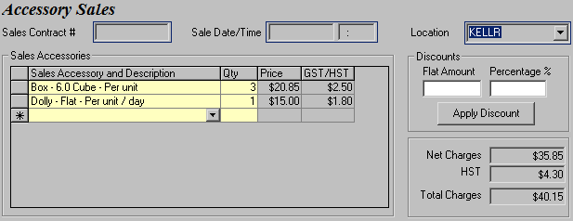

To add a discount, you must first select the item you want to apply the discount to. In our example, this discountable item would be the 6.0 Cube box, so click on the grey cell beside the box (as shown in the red highlighted section) to highlight the box item.
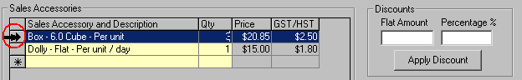

Now enter 5 in the Percentage % field to apply a 5% discount to the boxes.
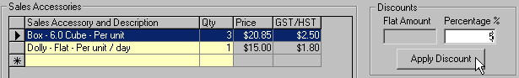

When you click Apply Discount, the discount appears in a new row in the Sales Accessories grid for the item that you selected, which is the 6.0 Cube box in this case. Notice that the Total Charges amount is also updated automatically to reflect the discount.
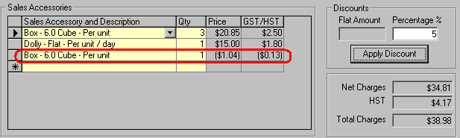

It is possible to apply different discounts to different items. Continuing from our example above, let’s assume that Jon the customer decides to use a $1 coupon he printed off www.budget.com in this transaction.

Recall that you need to select a sales accessory before you can apply a discount and since the discount amount is only $1, you can apply it to either the 6.0 cube boxes or the flat dolly since both their prices are higher than $1. GIS will not allow you to apply a flat discount to an item with a lower price than the discount amount.

Let’s go ahead and apply the $1 discount to the flat dolly. First, remove the ‘5’ from the Percentage % box because we now want to apply a flat amount.

Enter ‘1’ in the Flat Amount field and select the flat dolly (to apply the discount to) by highlighting it.
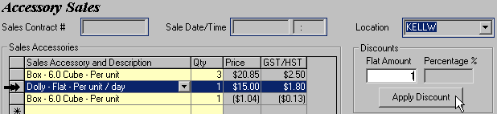

When you hit Apply Discount, once again the discount appears in a new row in the Sales Accessories grid for the item that you selected, which is the flat dolly in this case. Notice that the Total Charges amount is also updated.
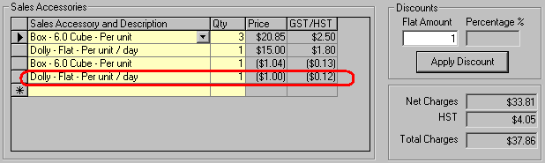

NOTE FOR ACCOUNTING STAFF
The discount added will correspond to the GL number of the item it is applied to.

For example:
If the GL account for the 6.0 cube box and flat dolly are as below,

Sales Accessory GL Account
6.0 cube box 1011-00
Flat dolly 1022-00

Then the GL account number for the 5% discount applied to the 6.0 cube box would be 1011-00 and the $1 discount added to the flat dolly would be 1022-00.

Adding a percentage discount to all items in Accessory Sales

Let’s open a new sales contract for Mary. Select the items she requested in the Sales Accessories section.

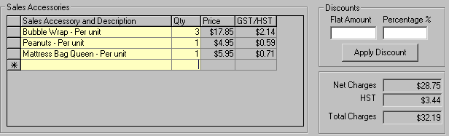

To apply a 10% discount to all sales accessories in your contract, you would need to enter the discount value in the Percentage % field, then select all item in the grid and click Apply Discount.

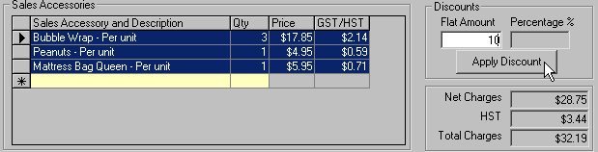

Your final screen should look like the screenshot below.
